**GitHub Assignment 1**

**Nawal Mohamed Jaffar**

**4MH21IS050, 7th Semester**

**Maharaja Institute of Technology, Mysore.**

**GitHub Assignment 1**

**Snapshots :**

1. 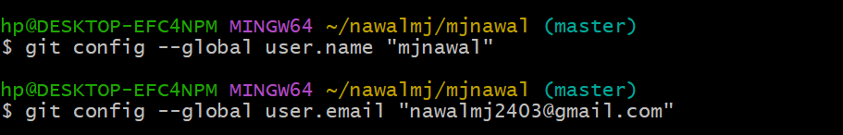**Configure your Git with your name and email. ✍️**
2. **Clone the project repository from GitHub. 🔄**

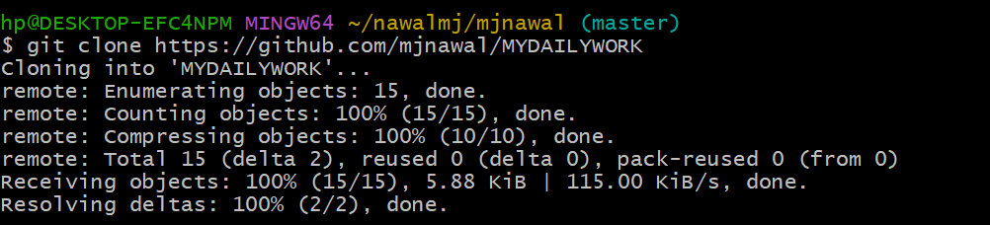

1. **Create a new feature branch. 🌿**
2. **Add a new file called feature.py to your branch📂**

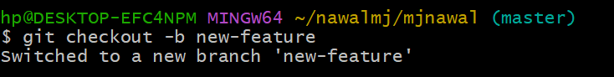

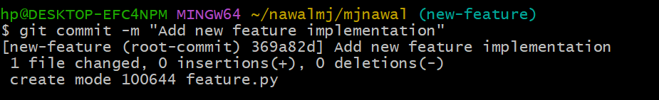 **5. Commit your changes with a message. 💬**

1. 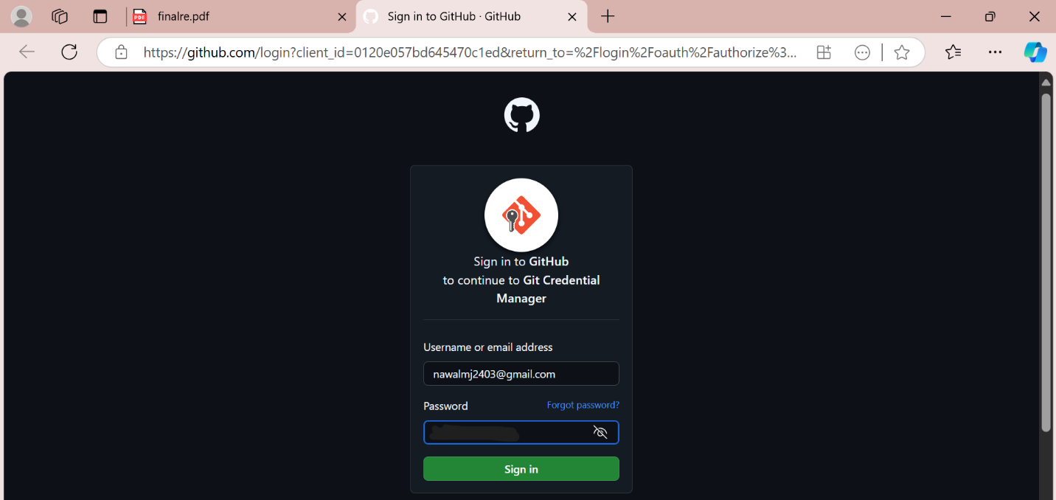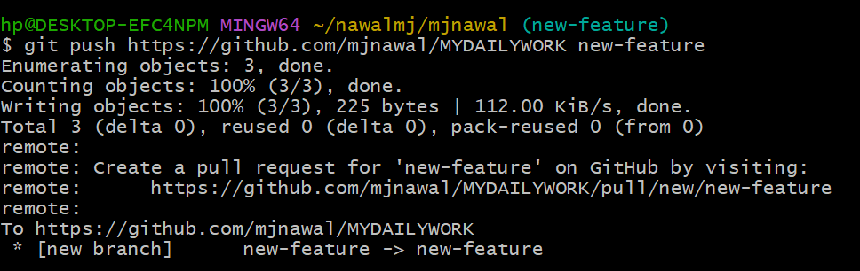**Push your changes to the remote repository. 🚀**

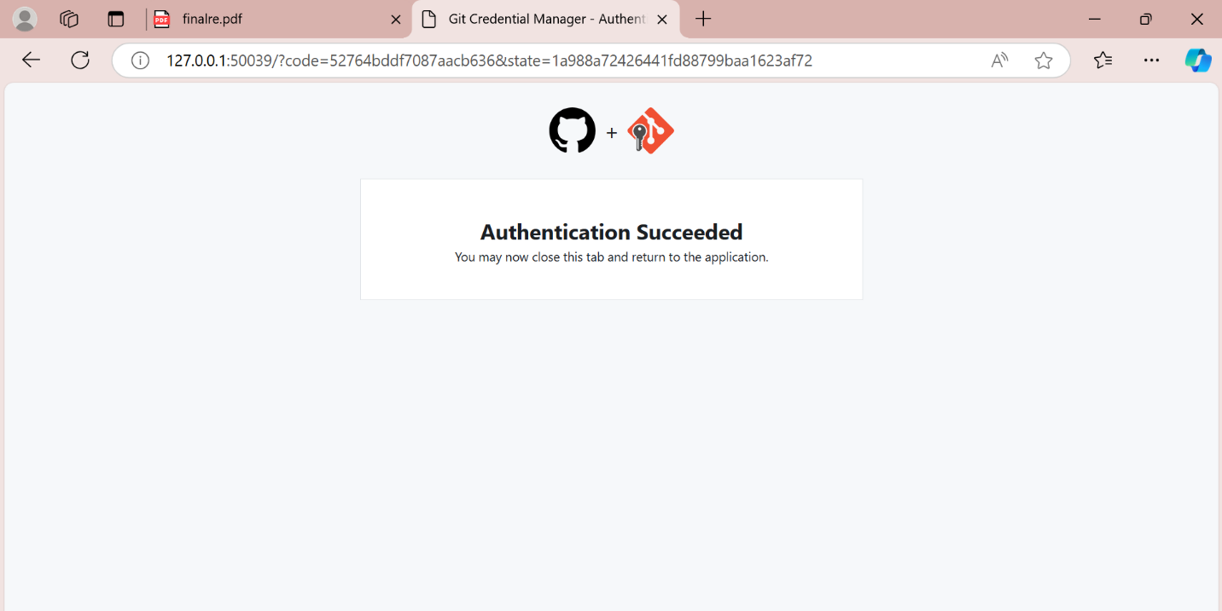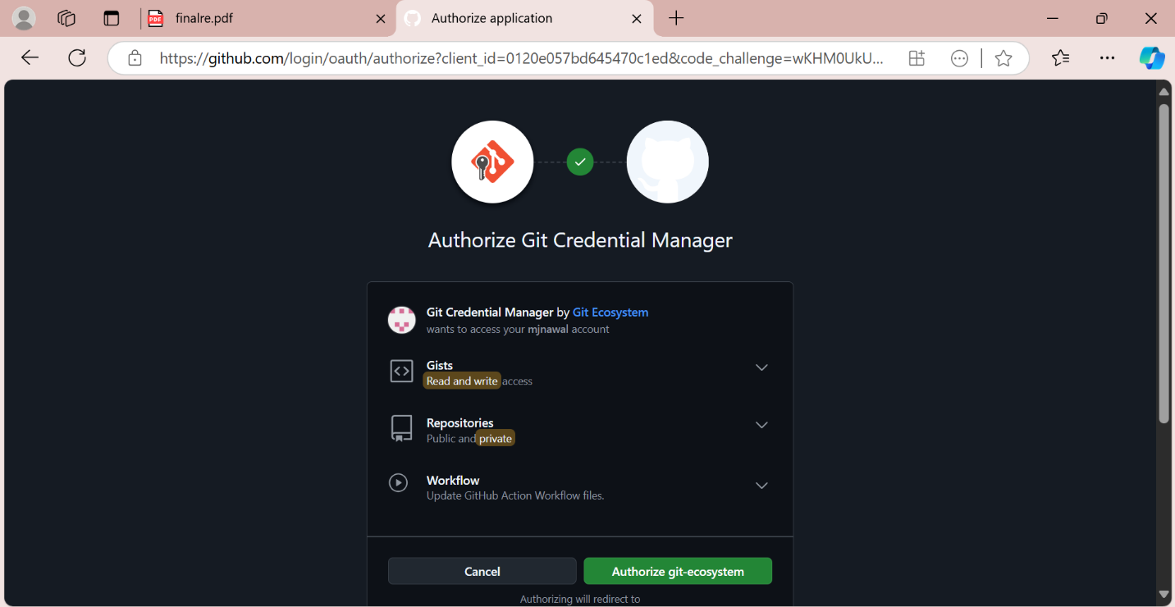

1. **Pull the latest changes from the main branch. ⬇️**

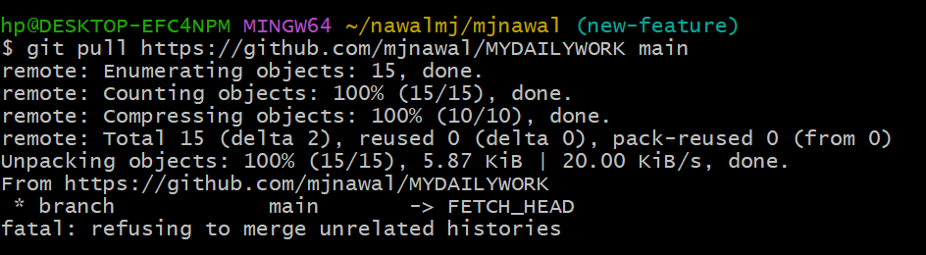

1. **Remove the feature.py file from your branch. ❌**
2. 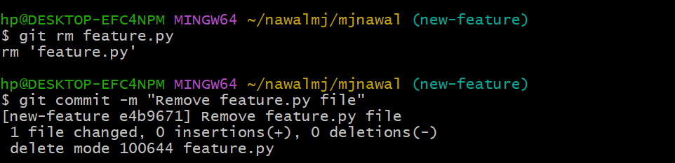**Commit the removal of the file and push the changes. 📤**

**Commands:**

**1. git config --global user.name "mjnawal"**

**2. git config --global user.email** [**nawalmj2403@gmail.com**](mailto:nawalmj2403@gmail.com)

**3. git clone** [**https://github.com/mjnawal/repo.git**](https://github.com/mjnawal/repo.git)

**4. git checkout -b new-feature**

**5. git add feature.py**

**6. git commit -m "Add new feature implementation"**

**7. git push origin new-feature**

**8. git pull origin main**

**9. git rm feature.py**

**10. git commit -m "Remove feature.py file"**

**11. git push origin new-featur**